# INFORMATION TECHNOLOGY APPLICATIONS

**TRANSITION WORKBOOK**

**UNIT 3 OUTCOME 1**

**VCAA Study Design 2011-2014**

*“Students investigate types of online communities and their needs, and the types, purposes and functionality of specific types of websites that support information exchange, including wikis, blogs, forums (chat rooms) and social networking sites”.*

***Key Knowledge:***

* *types, purposes and functionality of websites that support information exchange within online communities*
* *types and purposes of online communities including social, work-based, project/interest-based that support the purposes of collaboration, knowledge sharing and collective identity*
* *needs of online community members that affect the nature of their websites, including access requirements (open or closed)*
* *non-technical constraints on website solutions, including privacy, copyright and human rights requirements and social online protocols”*

*(10 other Key Knowledge Dot Points will be covered in U3O1)*

**ONLINE COMMUNITY:**

An online community is a group of people, with a common interest, that use the internet to work, socialise or communicate with each other.

**TYPES OF WEBSITES:**

Wikis, Forums, Blogs, Social Networking, Chat Rooms

**TYPES OF ONLINE COMMUNITIES:**

Social, Work-based, Project/interest based

**SOCIAL ONLINE PROTOCOLS:**

Accepted ways of behaving on websites that support communication. Protocols usually relate to identity, the nature of the information exchanged, language used in communications and rights of members. Breaches of social online protocols include fraudulent identity, cyberbullying, harassment, posting of inappropriate information and use of inappropriate language

**Task 1: Social Networking**

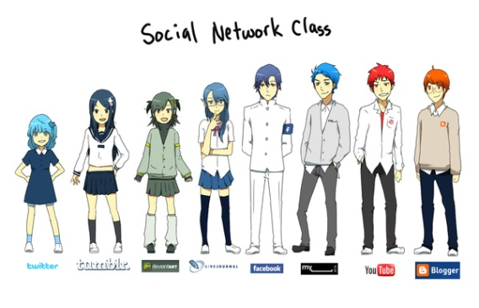Online communities use social networking services to share interests, collaborate and exchange information and knowledge. Users build on-line profiles that include pictures, blog entries, etc.



<http://www.geekstir.com/if-social-networking-sites-were-people> <http://mynerdblog.com/2011/09/social-network-class-anime-style/#axzz1dlJtGWRZ>

Using the above graphics, explain how the characteristics of two (2) social networking sites are depicted.

**Task 2: Social Media**

Watch the following YouTube videos and then list 10 amazing facts you did not know beforehand.

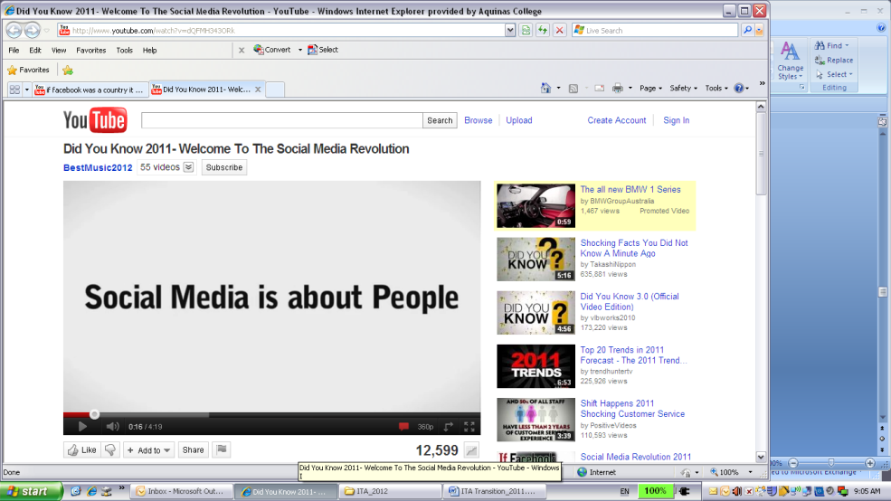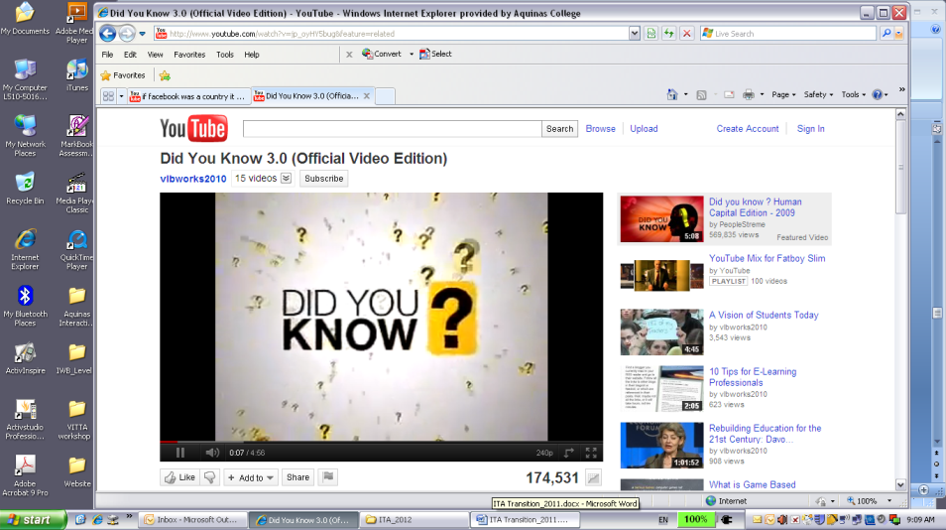

<http://www.youtube.com/watch?v=jp_oyHY5bug&feature=related> <http://www.youtube.com/watch?v=dQFMH343ORk>

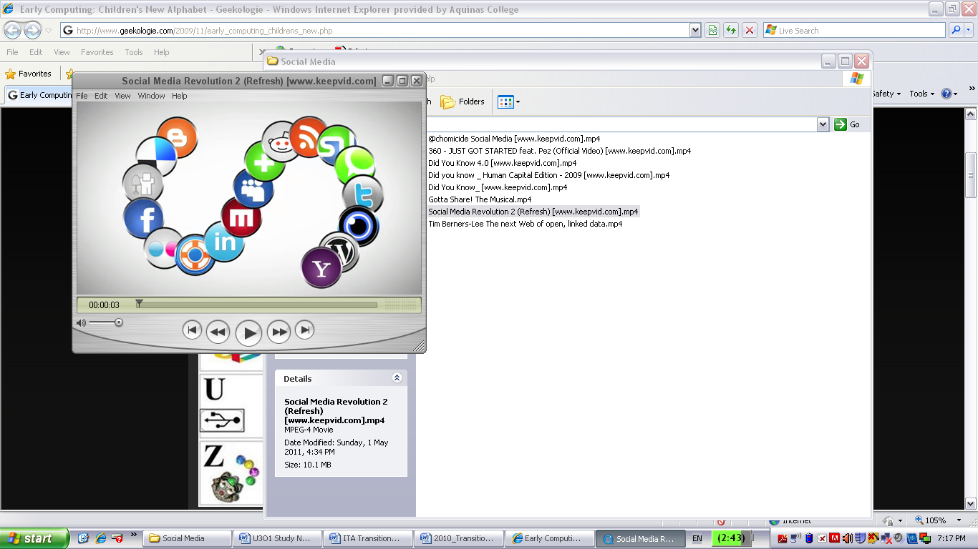

<http://www.youtube.com/watch?v=lFZ0z5Fm-Ng>

**Task 3: Early Computing: Children’s New Alphabet**

Referring to the image below, what does each letter of the alphabet represent?

[**http://www.geekologie.com/2009/11/early_computing_childrens_new.php**](http://www.geekologie.com/2009/11/early_computing_childrens_new.php)

**Task 4: Social Media & Life**

Optimisng.com.au interviewed Corey Williams (basketball), Broni (singer) and 360 (rapper) on how they use social media. Select one of the interviews, and explain four (4) reasons how social media is used by the artist.

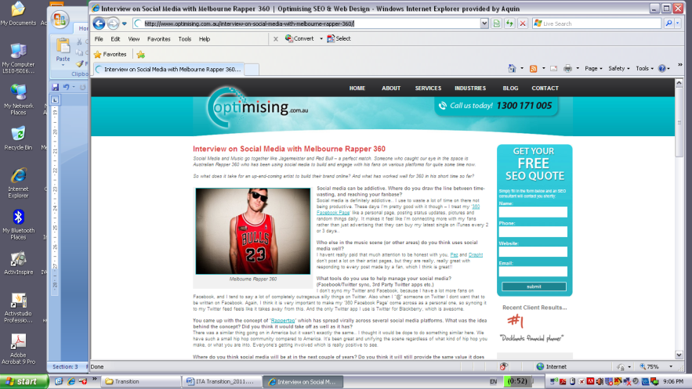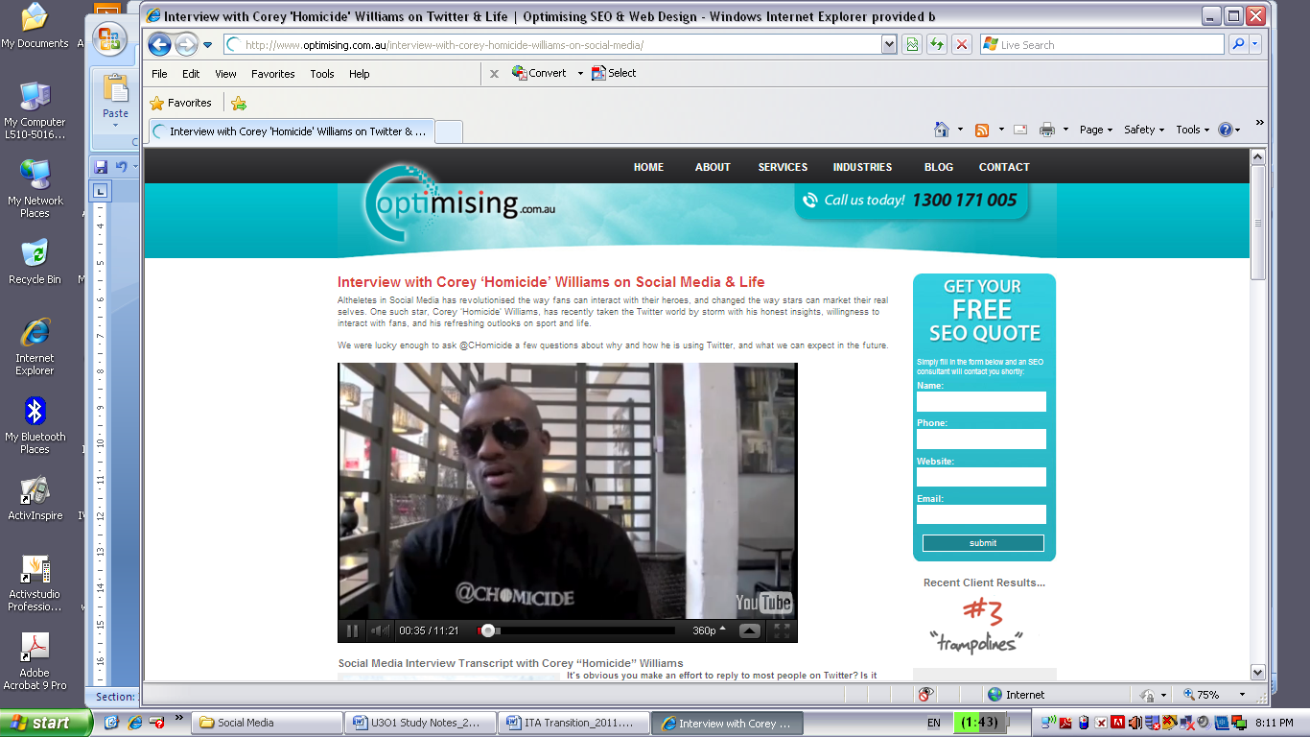

<http://www.optimising.com.au/tag/chomicide/> <http://www.optimising.com.au/interview-on-social-media-with-melbourne-rapper-360/>



<http://www.optimising.com.au/interview-with-melbourne-singer-songwriter-broni-on-social-media/>

**[](http://www.flowtown.com/blog/class-of-2011-if-social-media-were-a-high-school?display=wide)**

**Task 5: If social media was a high school…**

Explain the **purpose** of this infographic (200 words min.)

[**http://www.flowtown.com/blog/class-of-2011-if-social-media-were-a-high-school**](http://www.flowtown.com/blog/class-of-2011-if-social-media-were-a-high-school)